## UCR EE/CS 120B

## Lab 6: LCD Screen (1 Day)

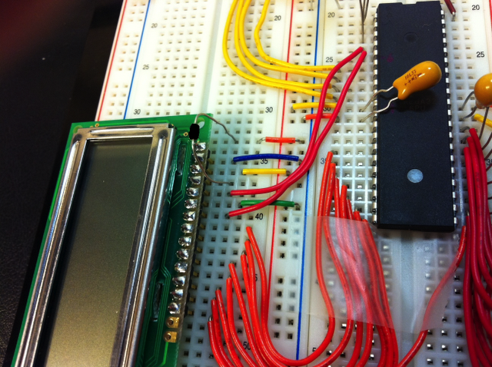

Figure 5: LCD Connections - Resistor is 10 kΩ (can be replaced with a 10 kΩ potentiometer). 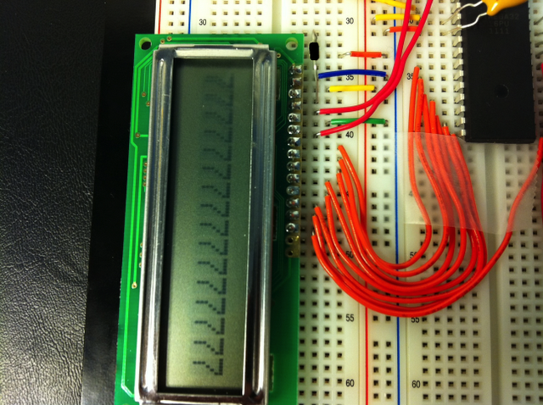

Figure 6: Functional LCD

Before using the LCD display, you will have to solder the display to the connector pins. Watch this youtube video before attempting to solder any connections. [How and WHY to Solder Correctly](http://www.youtube.com/watch?v=I_NU2ruzyc4). Here is the LCD [datasheet](https://docs.google.com/file/d/0B556Jee3EGgJR1lubnBNTkRPQVE/edit?usp=sharing).

LCD Display Pin Connections

|  |  |  |  |  |  |  |  |  |
| --- | --- | --- | --- | --- | --- | --- | --- | --- |
| **LCD**  **PIN #** | **1** | **2** | **3** | **4`** | **5** | **6** | **7-14** | **15-16** |
| Connection | GND | 5 Volts | Potentiometer  (10KΩ)  thru. to  GND | AVR PORT  D6 | GND | AVR PORT  D7 | AVR PORT  C0-C7 | Vcc-GND |

### 

The code provided in the files below provide a number of simple functions that can be used to write characters on the LCD display. Create a new folder called “includes”. Download the files below and store them in the “includes” folder. Follow the instructions in this [tutorial](https://docs.google.com/document/d/1mwsv6c4deh4EC0ALvY1og4eVfkw5he8NwsbWewdyHHA/edit?usp=sharing) to add the folder to the AVR Studio project.

[io.h](https://docs.google.com/file/d/0B556Jee3EGgJOW1nbDA3bjJSTEE/edit?usp=sharing)

[io.c](https://docs.google.com/file/d/0B556Jee3EGgJSFI1elJneEVGT0E/edit?usp=sharing)

If the LCD display has been connected according to the pinout given above, and the “io” files have been added to the working directory of the project, then the sample code below should print “Hello World” to the LCD display.

Sample LCD code: Copy, Paste, Save, Build, and Program this code into the micro-controller

#include <avr/io.h>

#include "io.c"

int main(void)

{

DDRC = 0xFF; PORTC = 0x00; // LCD data lines

DDRD = 0xFF; PORTD = 0x00; // LCD control lines

// Initializes the LCD display

LCD_init();

// Starting at position 1 on the LCD screen, writes Hello World

LCD_DisplayString(1, "Hello World");

while(1) {continue;}

}

The following three functions from “io.c” are the only functions that will be needed to operate the LCD display

LCD_ClearScreen(void): clears the LCD display

LCD_Cursor(unsigned char column): positions the cursor on the LCD display

LCD_WriteData(unsigned char Data): Writes a char at the position the cursor is currently in

LCD_DisplayString(unsigned char column, const unsigned char* string):

Writes a char* to the LCD display starting at position “column”

Each student must submit their .c source files according to instructions in the lab submission guidelines. Post any questions or problems you encounter to the wiki and discussion boards on iLearn.

|  |  |
| --- | --- |
| Knowing the current state of your program when testing is a critical debugging tool. A useful way to debug your program is to write the current state of your synchSM onto LEDs attached to an unused port. This approach gives you a visual representation of where your synchSM is at any given point. |  |

### Part B exercises

1. Buttons are connected to PA0 and PA1. Output PORTC and PORTD drive the LCD display, initially displaying 0. Pressing PA0 increments the display (stopping at 9). Pressing PA1 decrements the display (stopping at 0). If both buttons are depressed (even if not initially simultaneously), the display resets to 0. *If a button is held, then the display continues to increment (or decrement) at a rate of once per second.* Use a synchronous state machine captured in C.

**Note:** The LCD display displays ASCII values so 9 is not the same as ‘9’. For

displaying numbers 0 thru 9, a quick conversion technique is to add the

character ‘0’ to the number:

LCD_WriteData( 9 ); // will display nothing on the LCD

LCD_WriteData( 9 + ‘0’ ); // will display 9 on the LCD

**Video Demonstration:** [**http://youtu.be/cRNJc6lhcKs**](http://youtu.be/cRNJc6lhcKs)

1. (Challenge) Extend the earlier light game to maintain a score on the LCD display. The initial score is 5. Each time the user presses the button at the right time, the score increments. Each time the user fails, the score decrements. When reaching 9, show victory somehow.

**Video Demonstration:** [**http://youtu.be/r8yzRMPD3lE**](http://youtu.be/r8yzRMPD3lE)